<https://www.youtube.com/watch?v=NF5_btOaCig&list=PLblh5JKOoLUIzaEkCLIUxQFjPIlapw8nU&index=5>

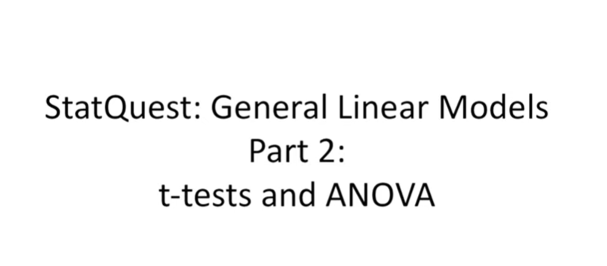

Hello and welcome to stat quest.

Stat quest was brought to you by the friendly folks in the genetics department at the University of North Carolina at Chapel Hill.

Today we're doing part 2 of our series on general linear models.

Last time we talked about how to do linear regression.

This time we're going to talk about how to use those exact same techniques to do t-tests and anova.

We'll do this using something called a design matrix which is a cool concept that we'll expand upon in future stat quests on general linear models.

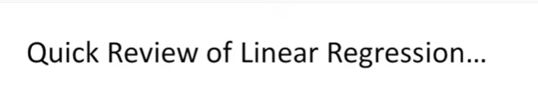

Let's start with a super quick review of linear regression.

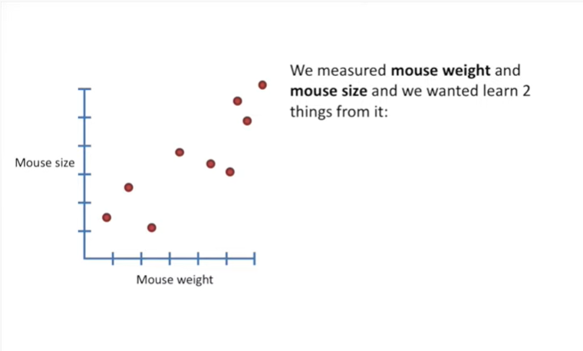

Last time we measured Mouse weight and mouth size and we wanted to learn two things from it :

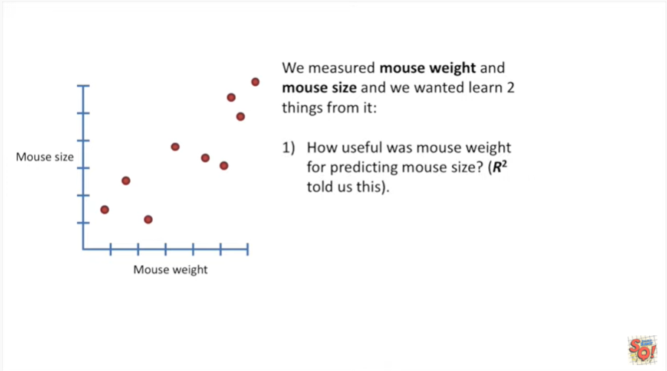

- we wanted to learn how useful Mouse weight was for predicting Mouse size.

R-squared told us this.

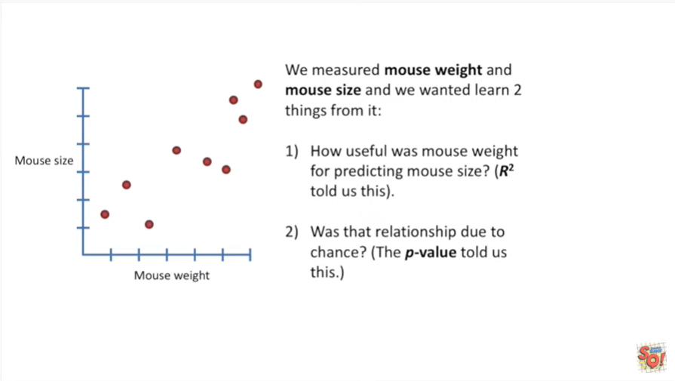

- and we wanted to know if the relationship was due to chance the p-value told us this.

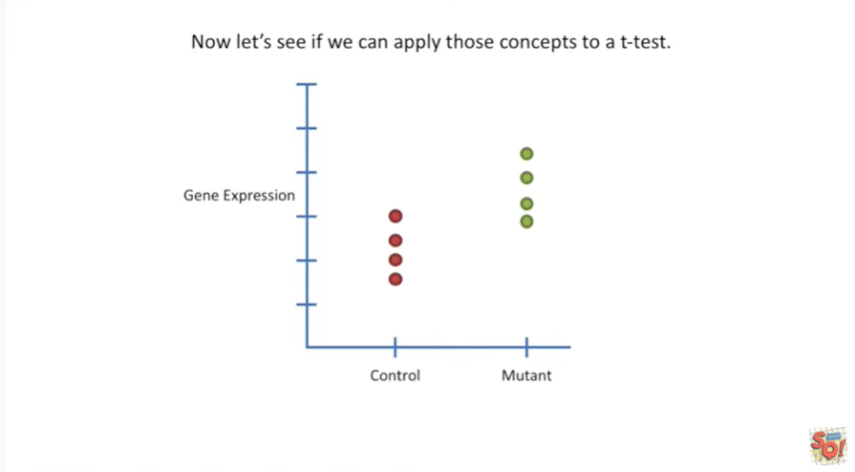

Now let's see if we can apply those concepts to a t-test.

In this specific example we're going to be comparing gene expression between control mice and mutant mice. Mutant mice are just normal mice that have a specific gene that's been knocked out and is no longer functioning correctly.

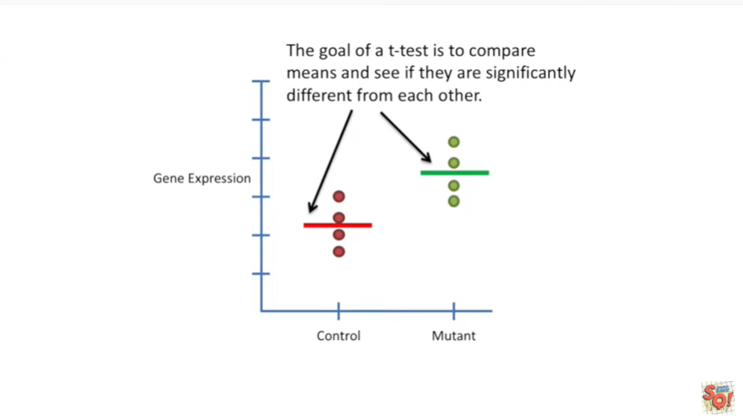

The goal of a t-test is to compare means and see if they are significantly different from each other.

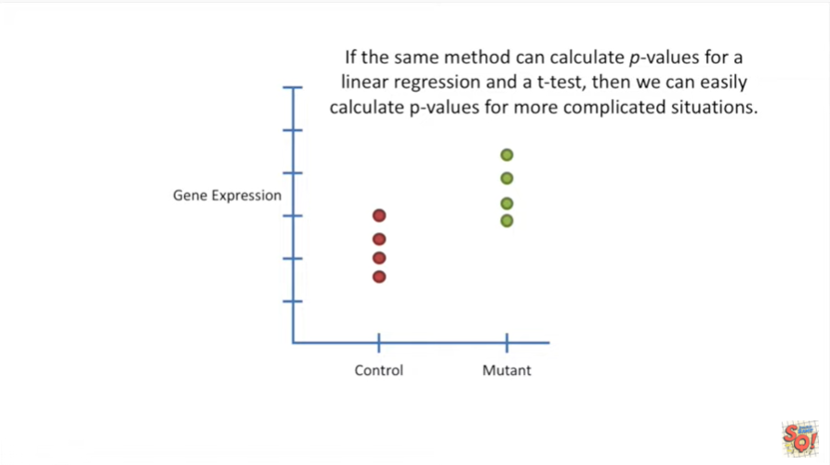

If the same method can calculate p-values for a linear regression and a t-test then we can easily calculate p-values for more complicated situations.

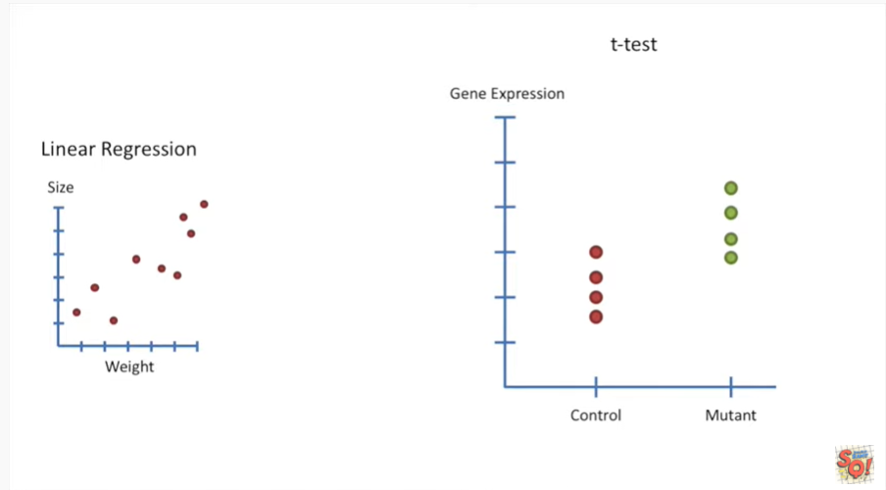

So now I'm going to walk you through the steps for using the techniques from linear regression to do a t-test.

On the left side of the screen I'll remind you how each step applies to linear regression.

On the right side of the screen I'll show you how those steps apply to T tests.

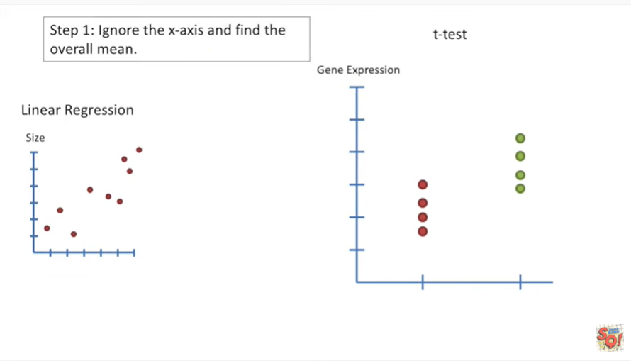

Step 1 ignore the x axis and find the overall mean.

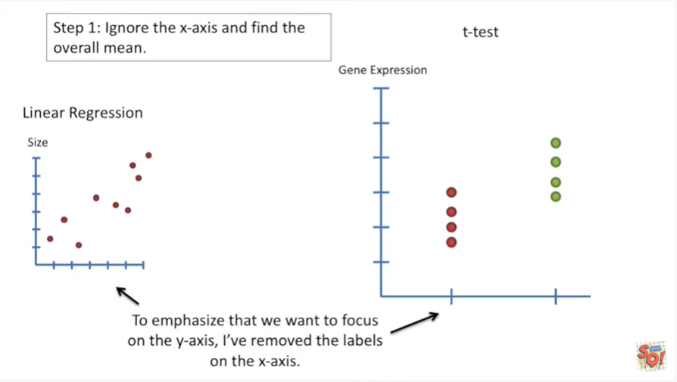

To emphasize that we want to focus on the Y access I've removed the labels on the x-axis.

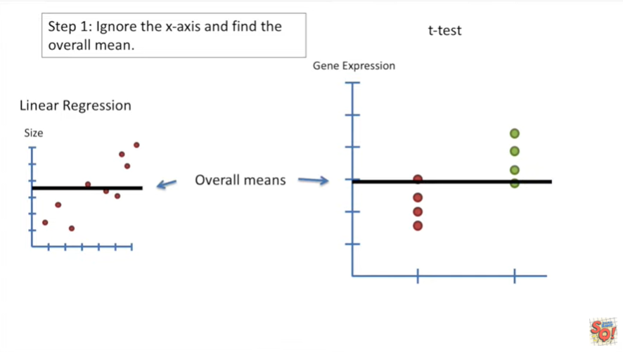

Here are their overall means for the linear regression and the t-test.

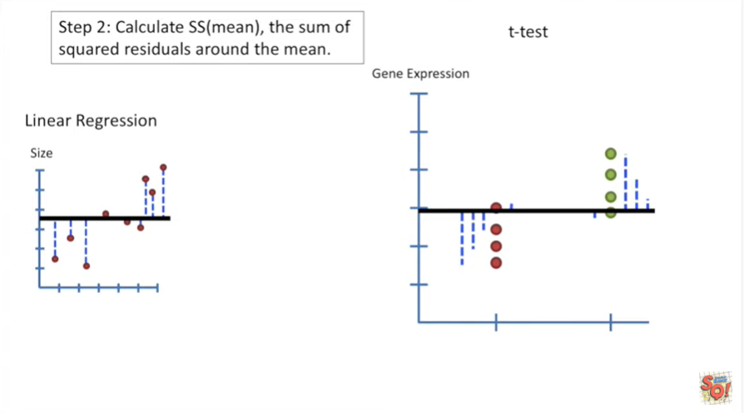

The next step is to calculate the sum of squared residuals around the mean.

This is SS mean.

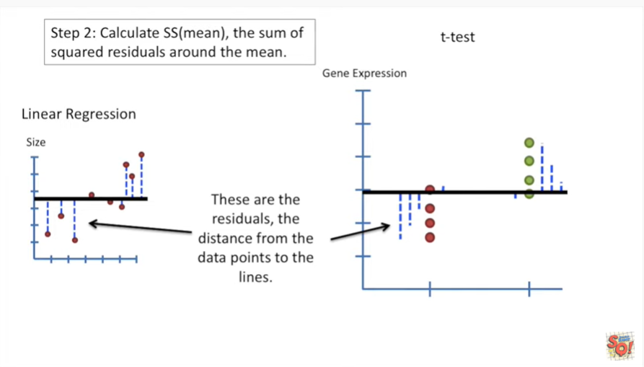

These are the residuals the distance from the data points to the lines.

In this case the lines are the overall means.

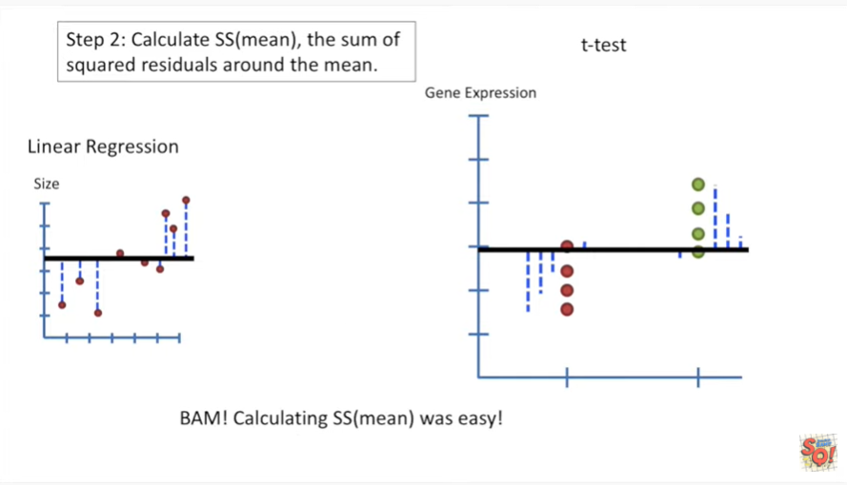

BAM.

Calculating the sum of squared residuals around the mean was easy.

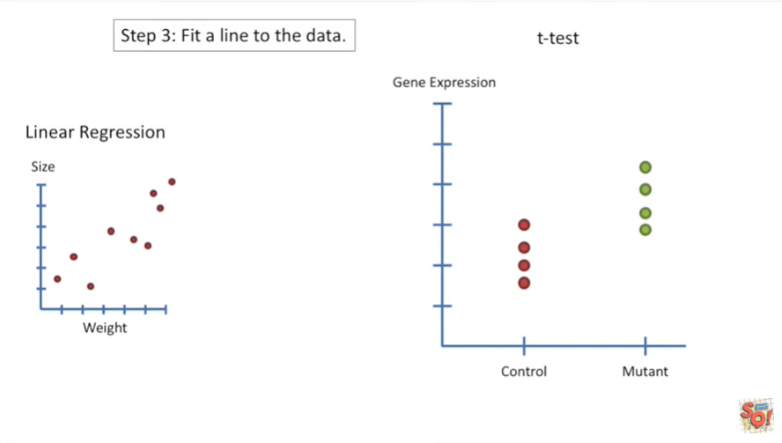

Step three fit alarm to the data.

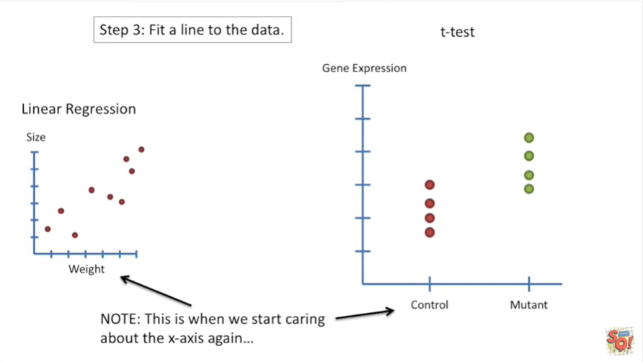

Note : this is when we start caring about the X access again.

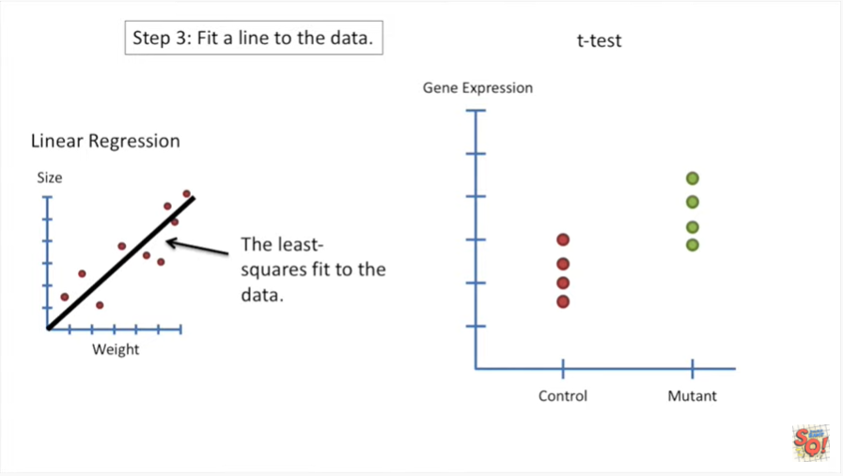

On the left side we have the least squares fit to the data.

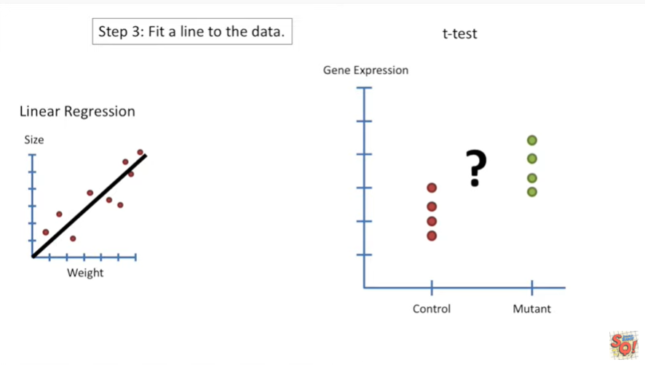

However how do we do a least squares fit to a t-test ?

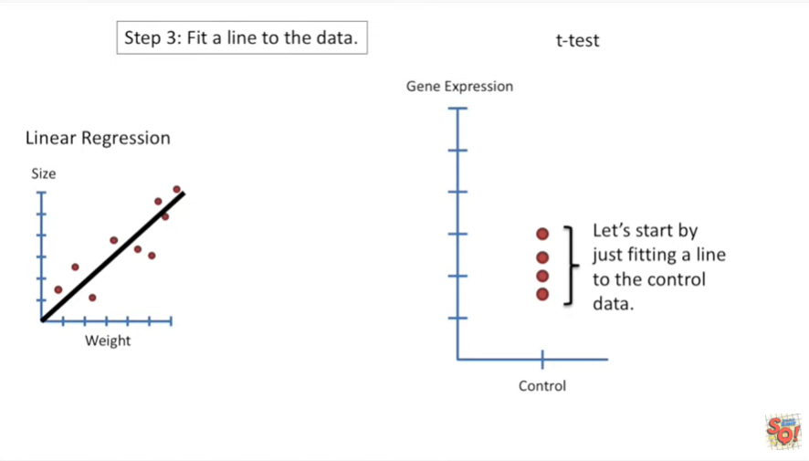

Let's start by just fitting a line to the control data.

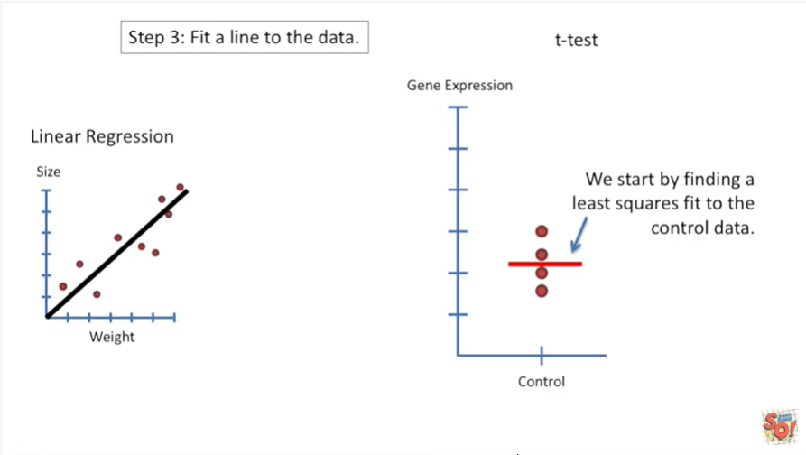

We start by finding a least squares fit to the control data.

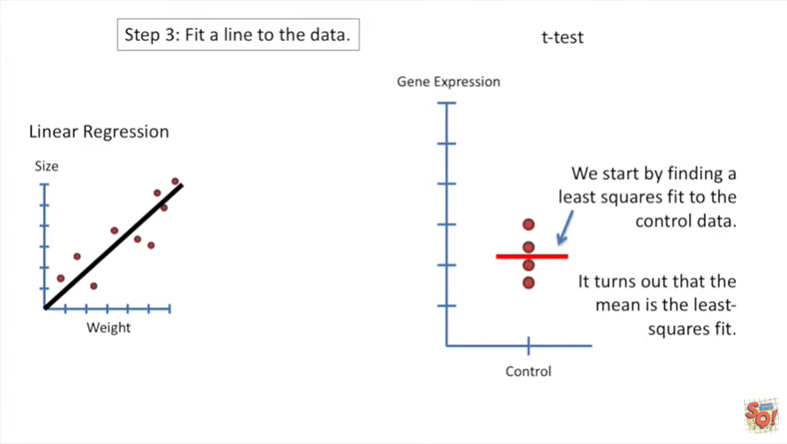

It turns out that the mean is the least squares fit.

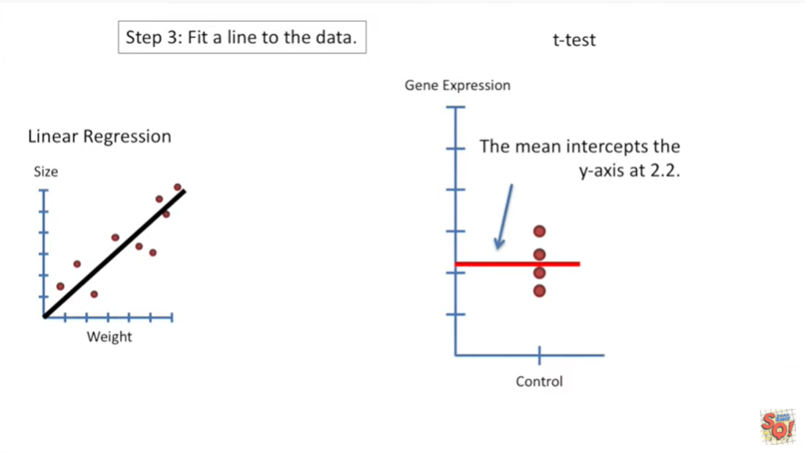

The mean intercepts the y axis at two point two.

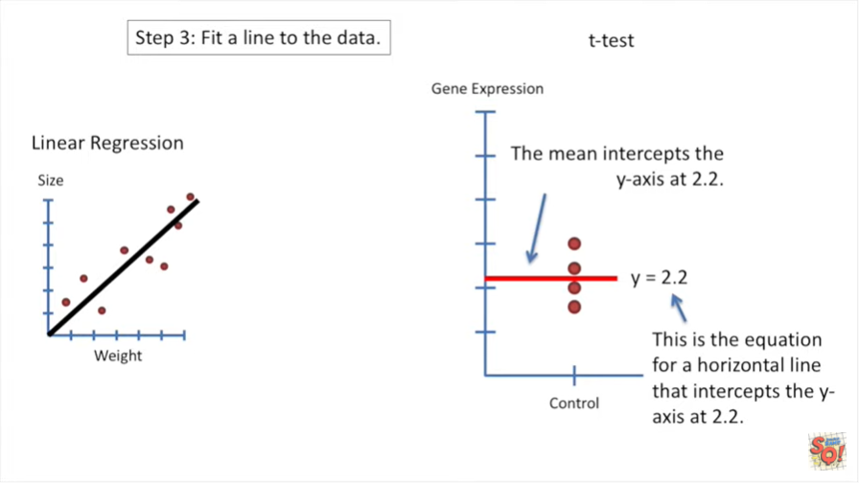

This is the equation for horizontal line that intercepts the y axis at two point two.

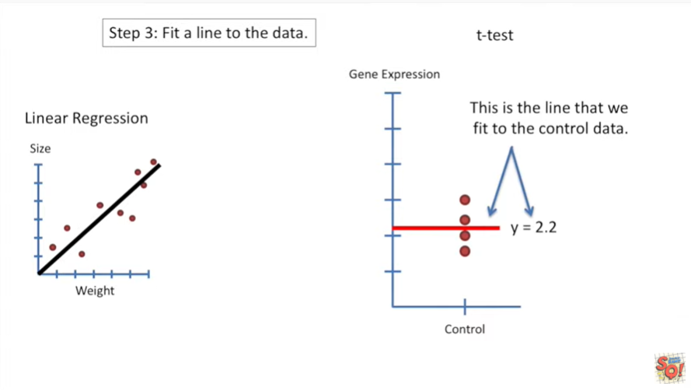

Thus this is the line that we fit to the control data.

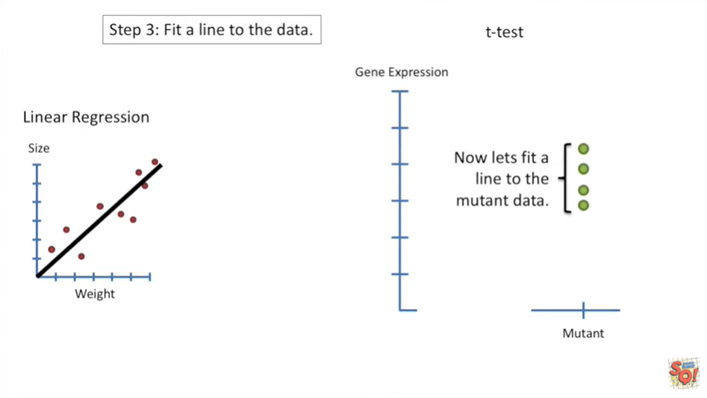

Now let's fit a line to the mutant data.

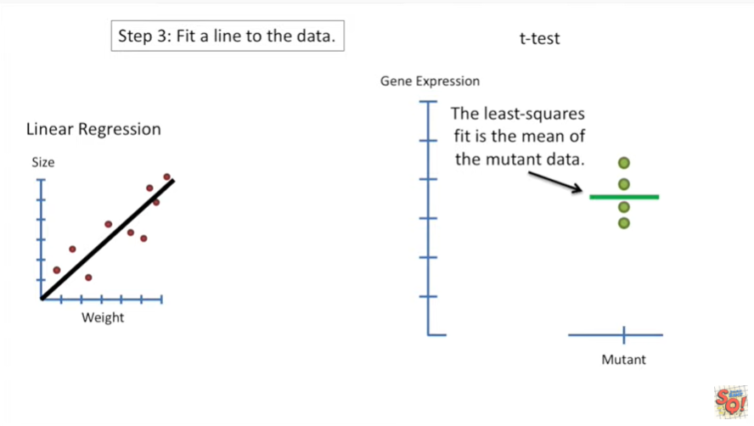

The least squares fit is the mean of the mutant data.

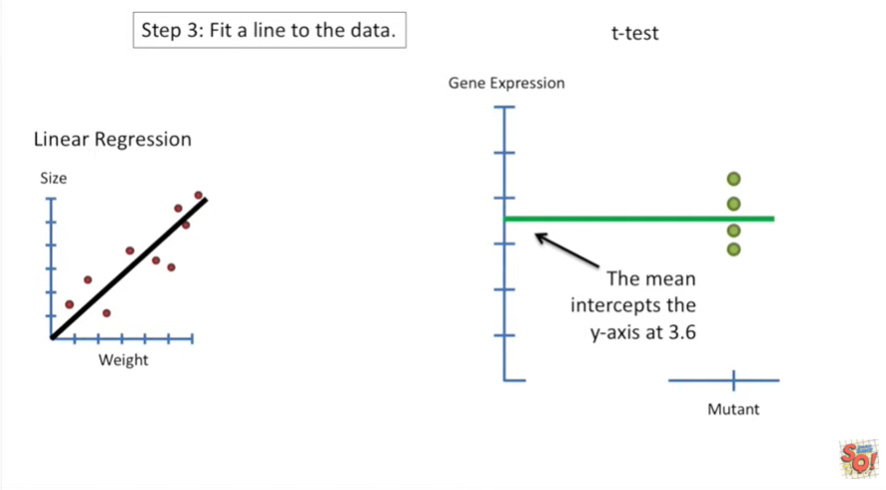

The mean intercepts the y axis at three point six.

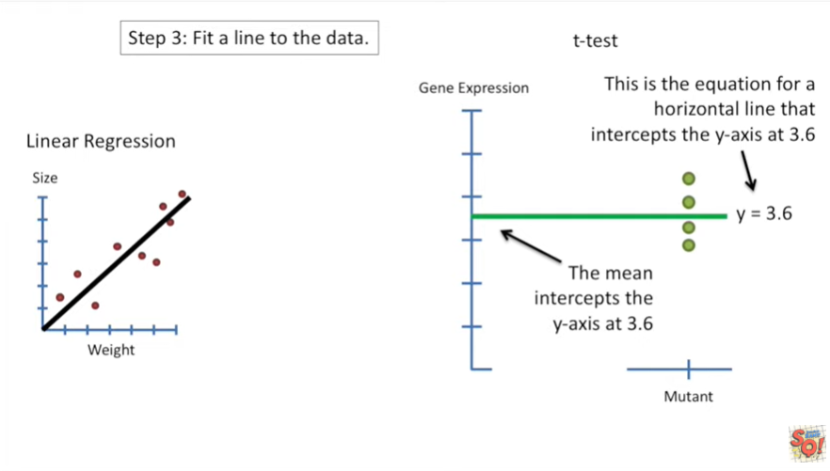

This is the equation for a horizontal line that intercepts the y axis at three point six.

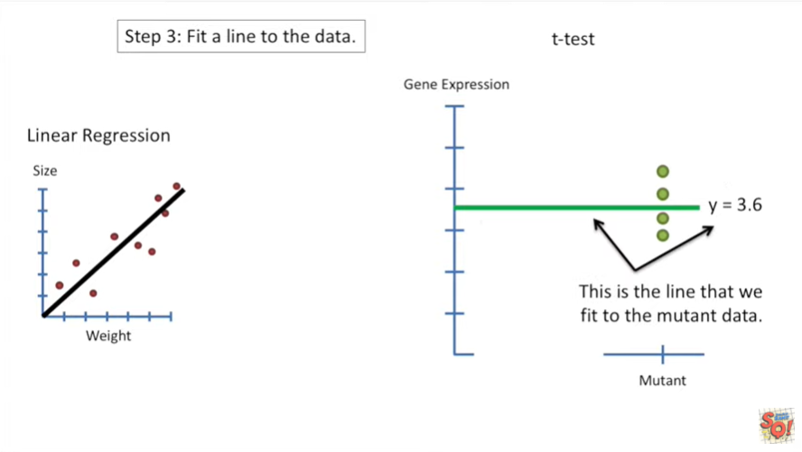

Thus this is the line that we fit to the mutant data.

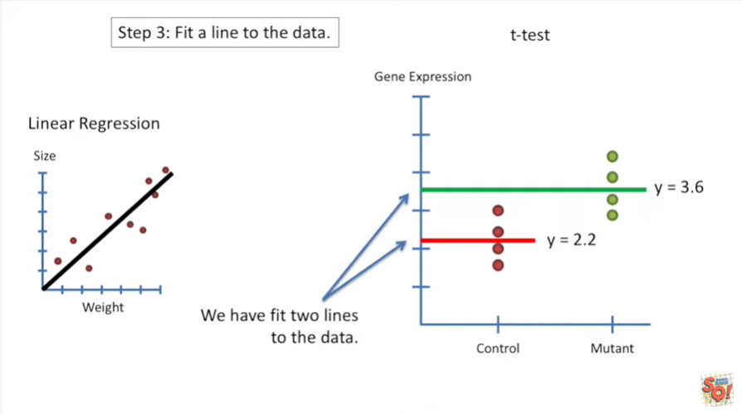

We have fit two lines to the data.

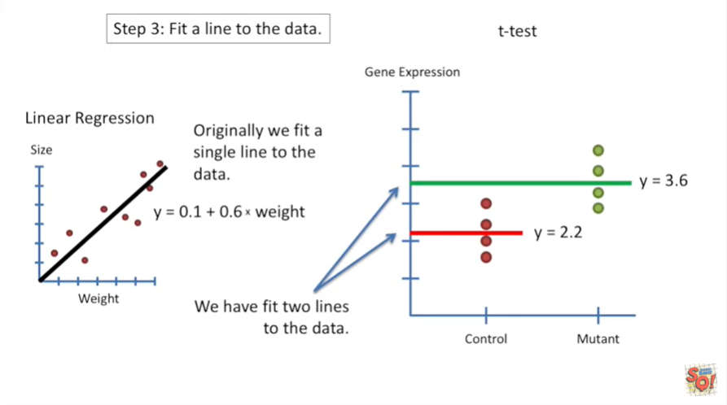

Originally when we did the regression we fit a single line to the data.

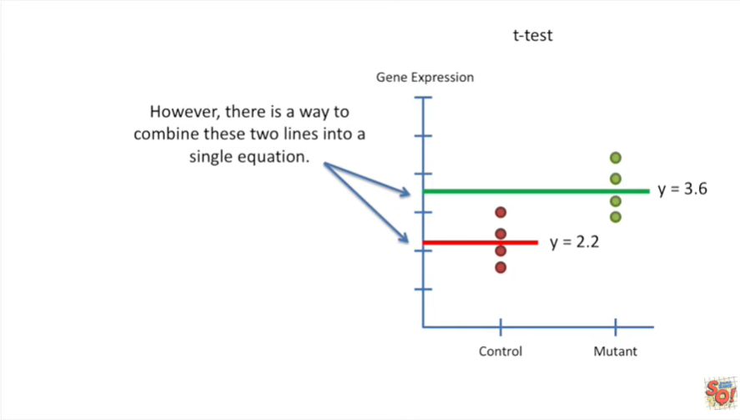

However there is a way to combine these two lines into a single equation.

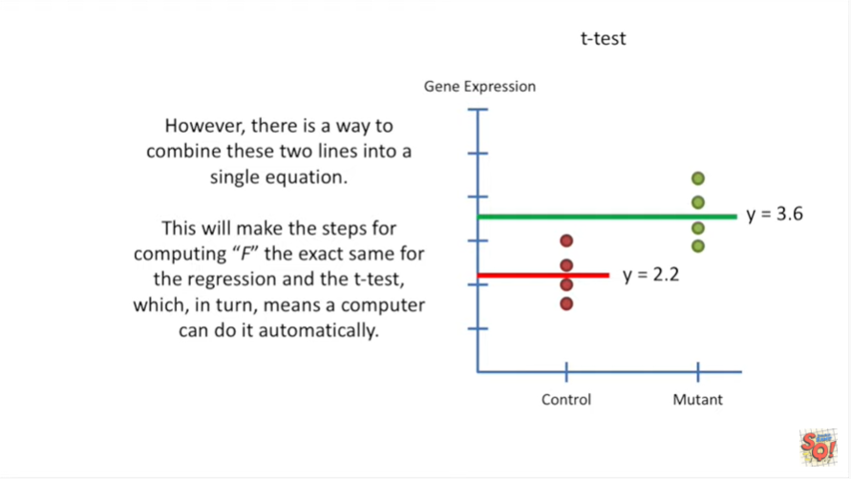

This will make the steps for computing f the exact same for the regression and the t-test which in turn means a computer can do it automatically.

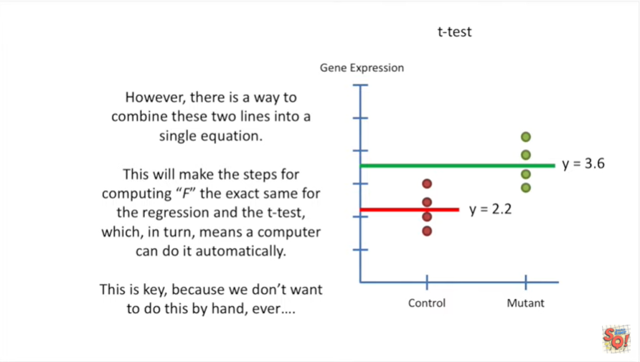

This is key because we don't want to do this by hand ever.

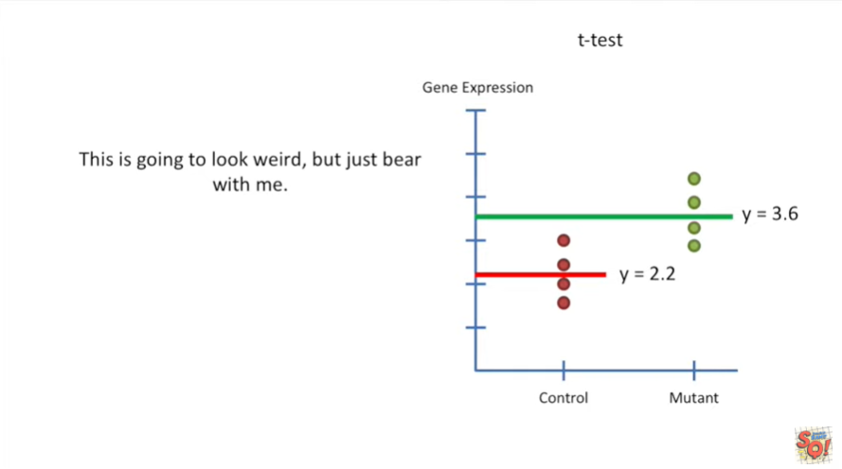

This is going to look a little weird but just bear with me.

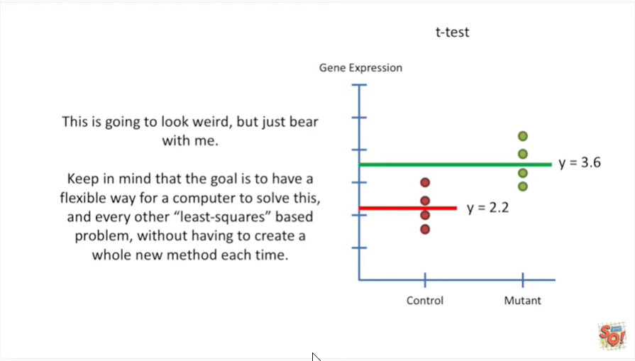

Keep in mind that the goal is to have a flexible way for a computer to solve this and every other least-squares based problem without having to create a whole new method each time.

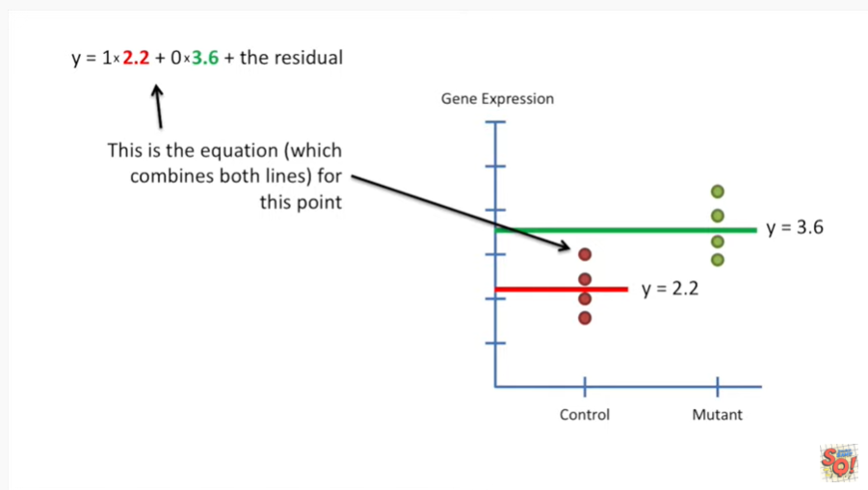

This is the equation which combines both lines for this point.

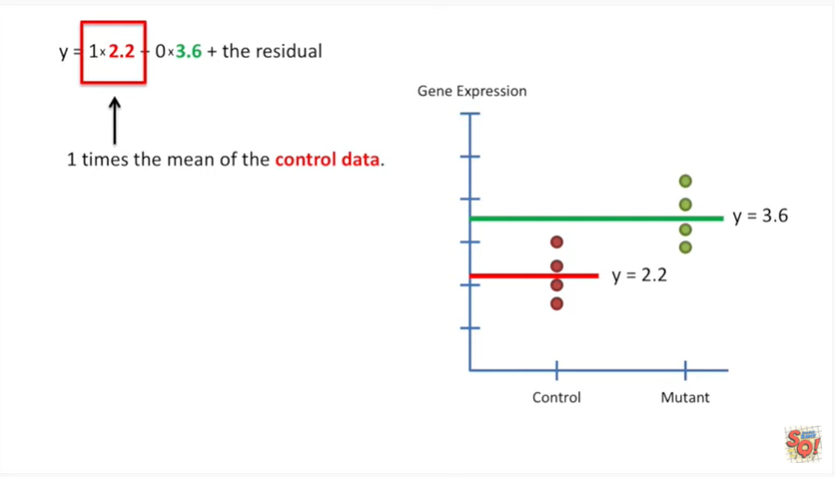

We have one times the mean of the control data.

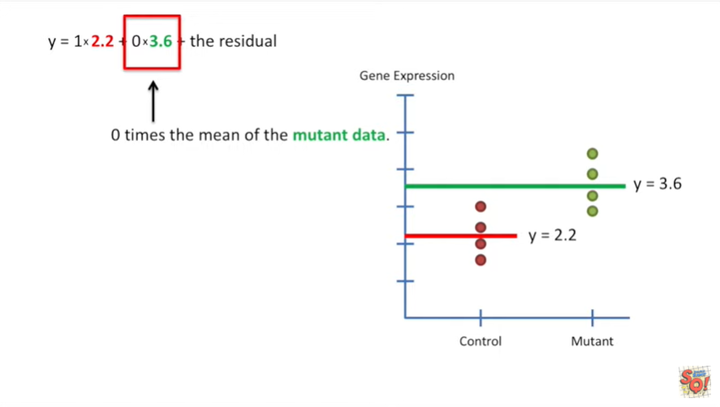

Zero times the mean of the mutant data plus the residual.

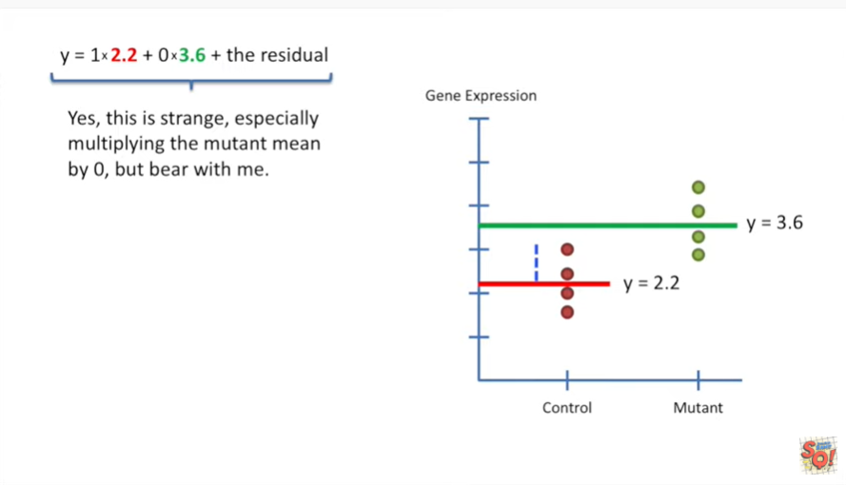

Yes this is strange especially multiplying the mutant mean by zero but bear with me.

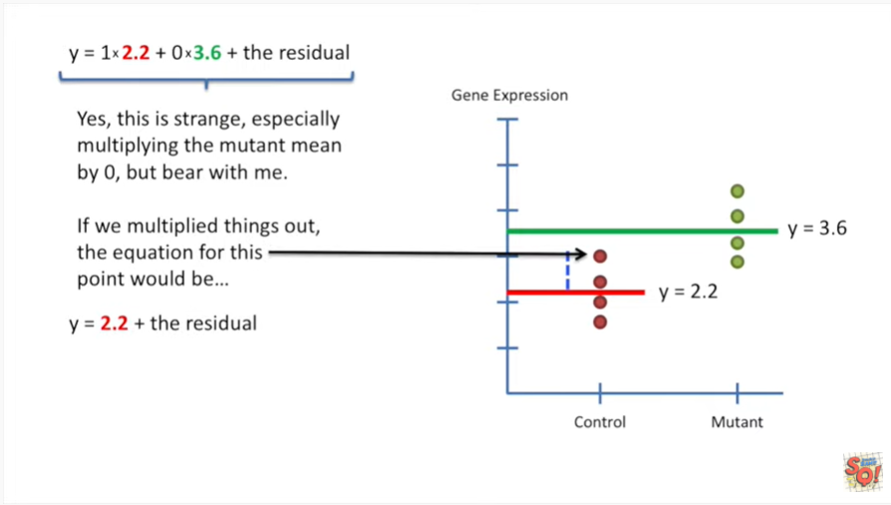

If we multiply things out the equation for this point would be y equals two point two plus the residual.

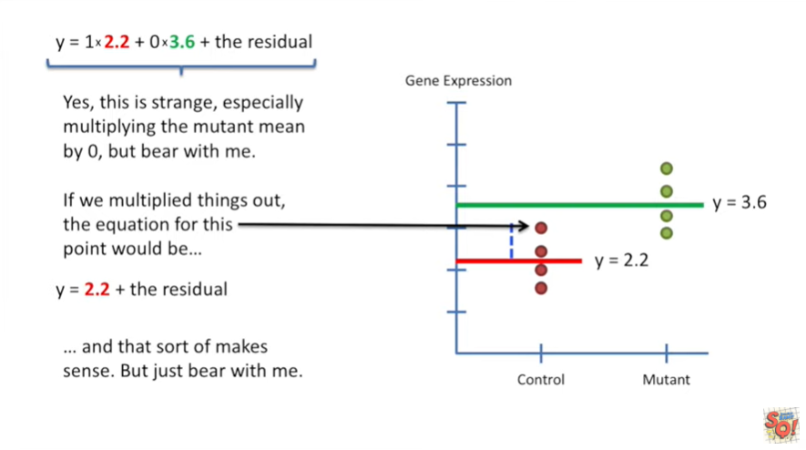 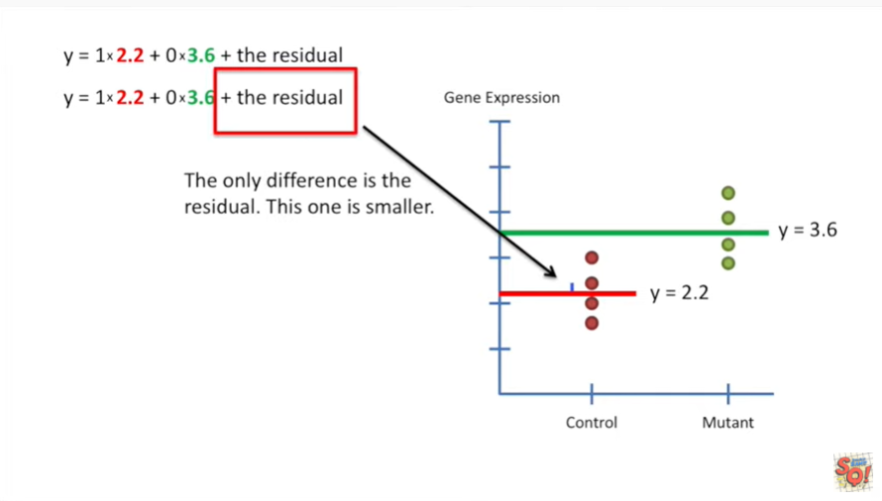

And that sort of makes sense but just bear with me.

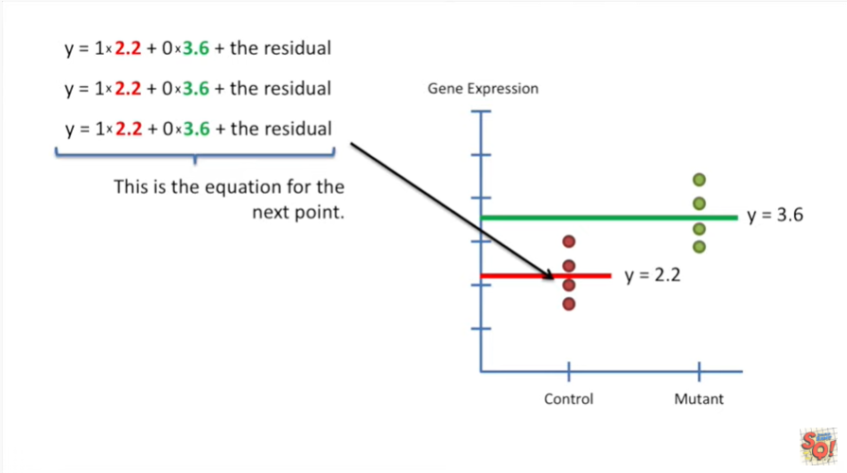

This is the equation for the next point.

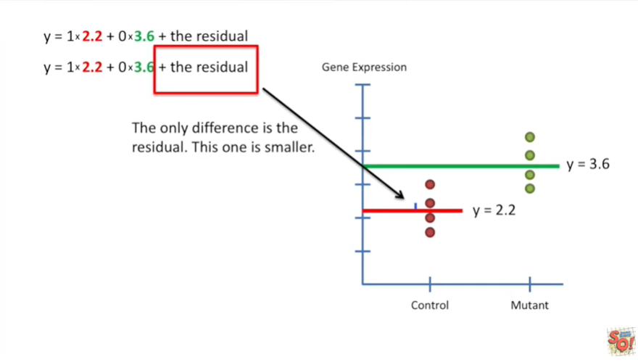The only difference is the residual, this one is smaller.

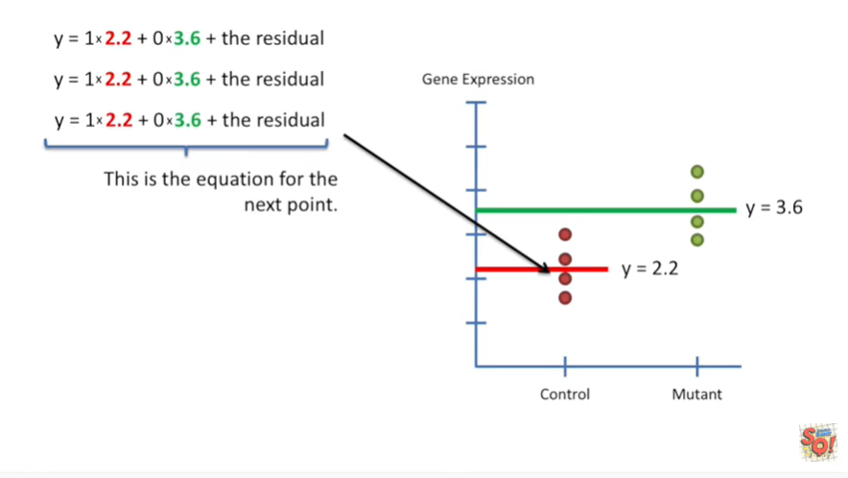This is the equation for the next point.

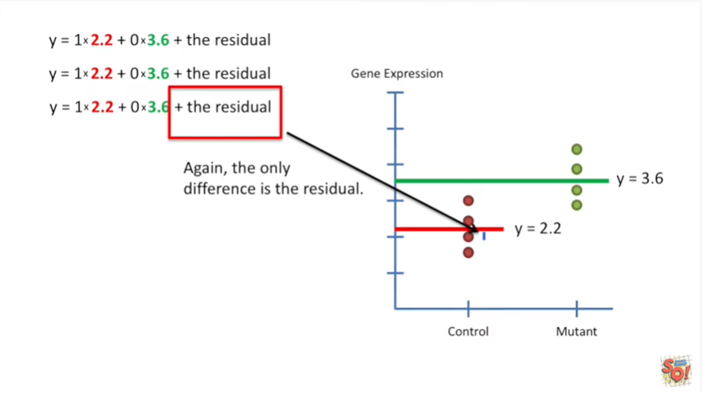Again the only difference is the residual.

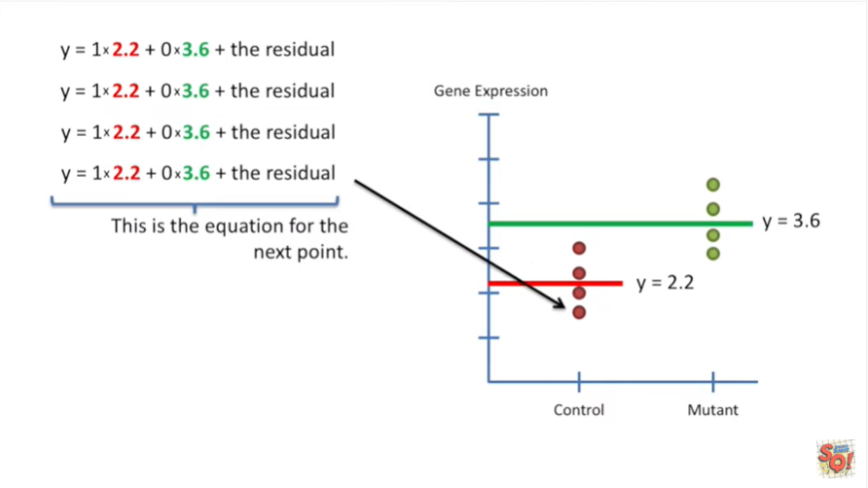This is the equation for the next point.

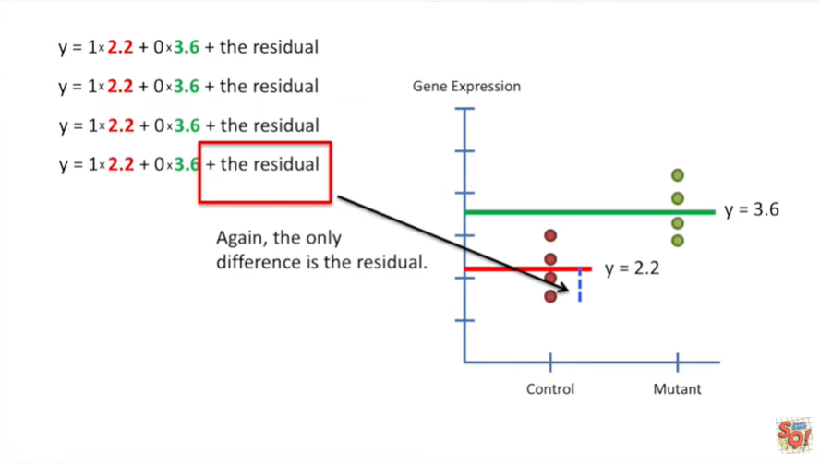And again the only difference is the residual.

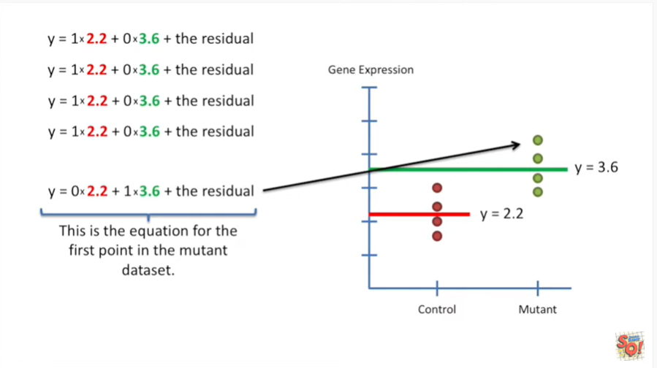

This is the equation for the first point in the mutant data set.

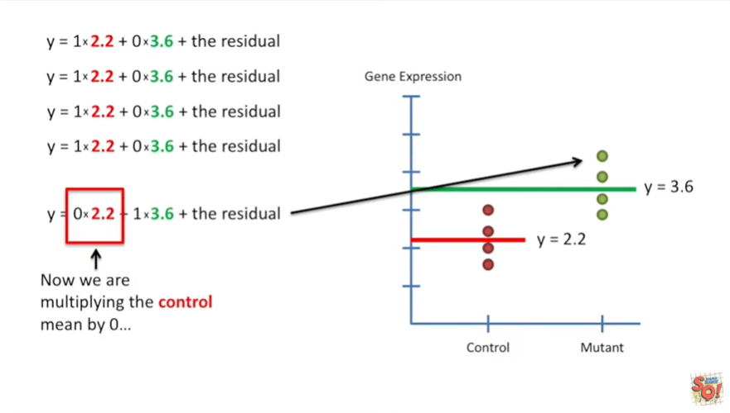

Now we are multiplying the control mean by zero.

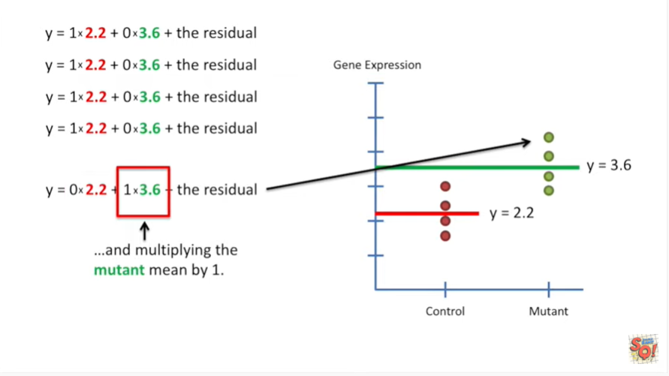

And multiplying the mutant mean by one.

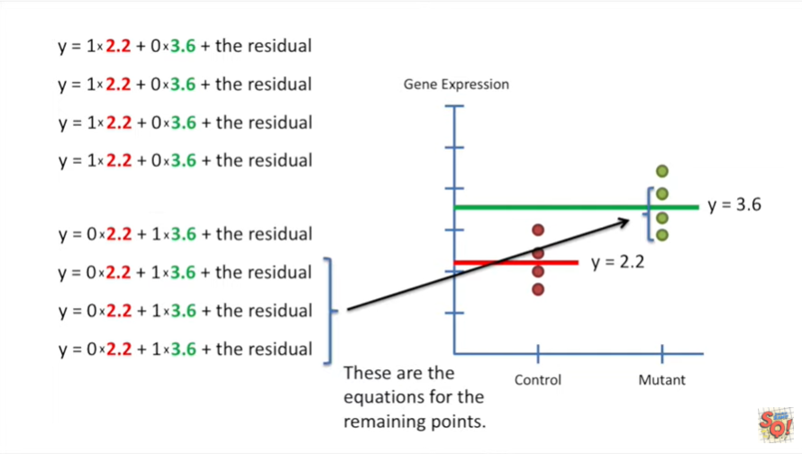

These are the equations for the remaining points.

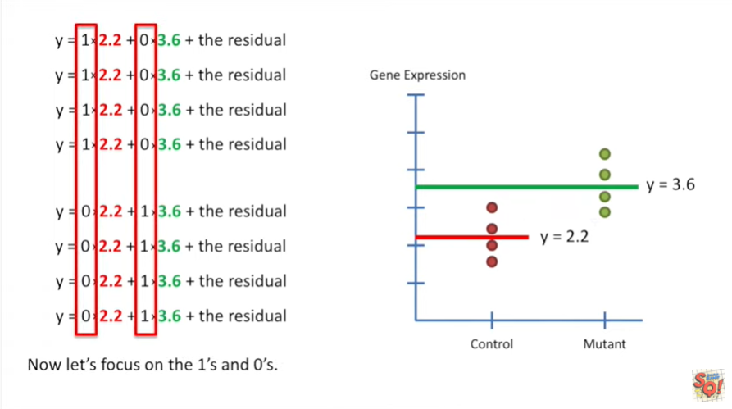

Now let's focus on the ones and zeros they function like on and off switches for the two means.

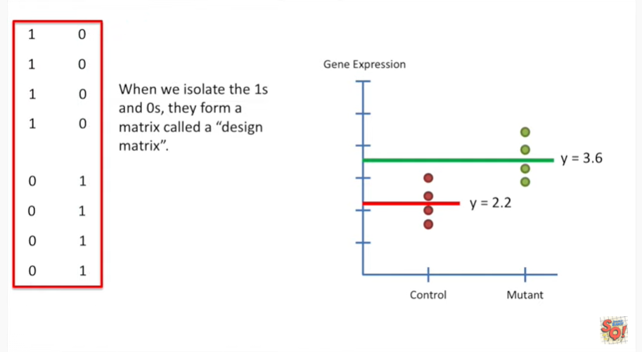

A one turns the mean on and a zero turns the mean off.

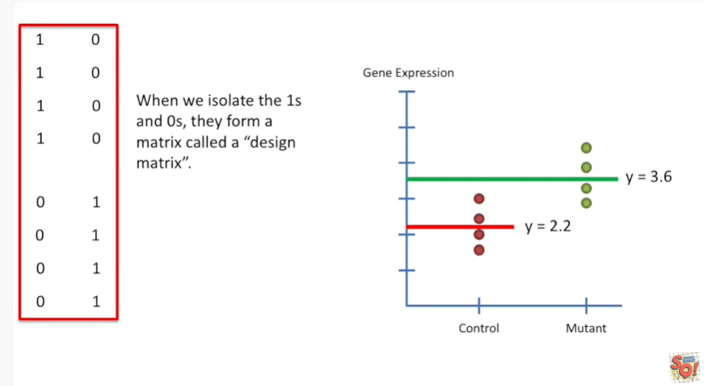

When we isolate the ones and zeros they form a matrix called a design matrix.

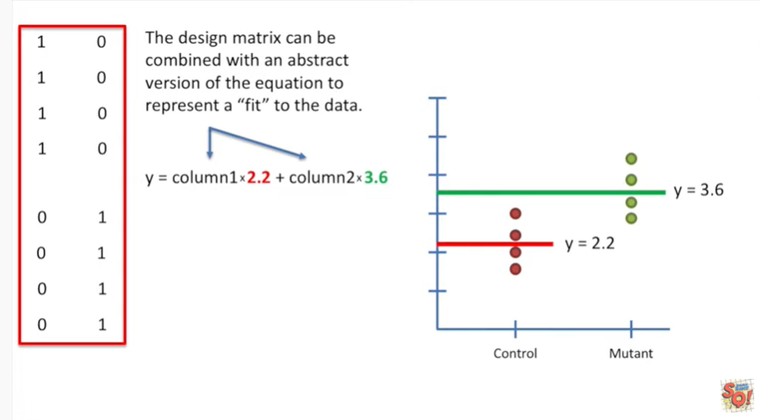

The design matrix can be combined with an abstract version of the equation to represent a fit to the data.

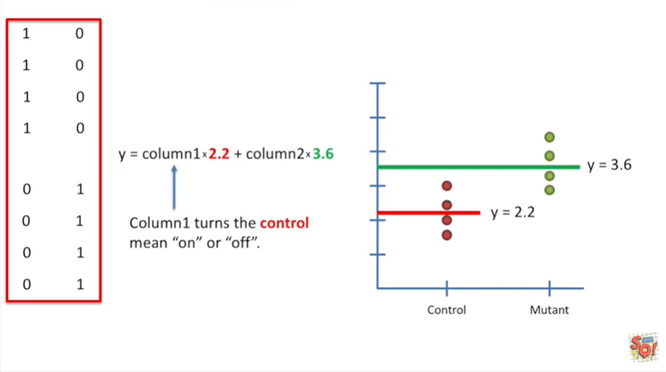

Column one turns the control mean on or off.

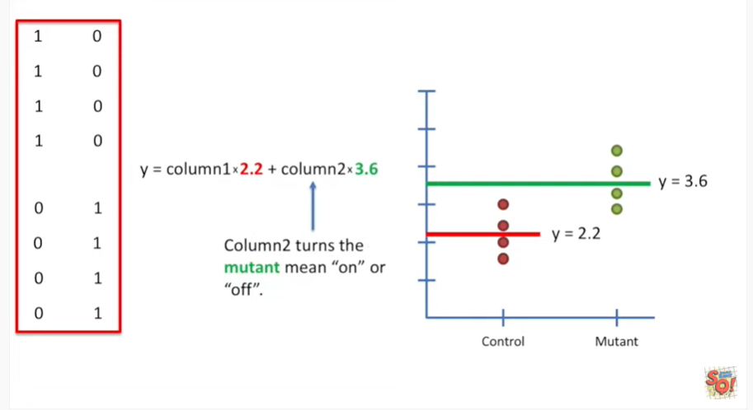

Column to turns the mutant mean on or off.

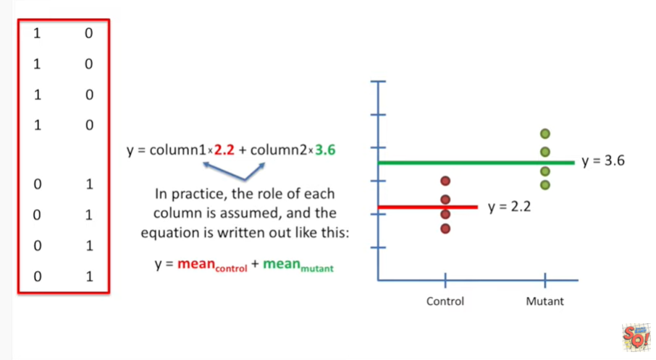

In practice the role of each column is assumed and the equation is written out like this.

Y equals the mean of the control data plus the mean of the mutant data.

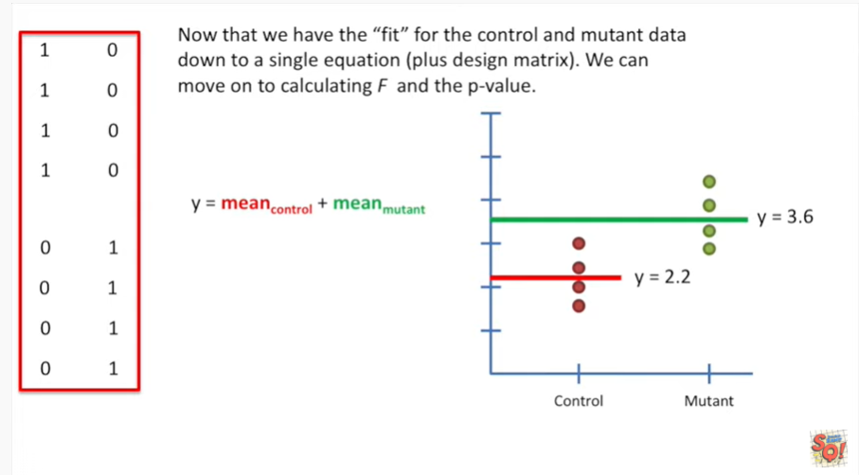

Now that we have the fit for the control and mutant data down to a single equation plus design matrix we can move on to calculating F and the p-value.

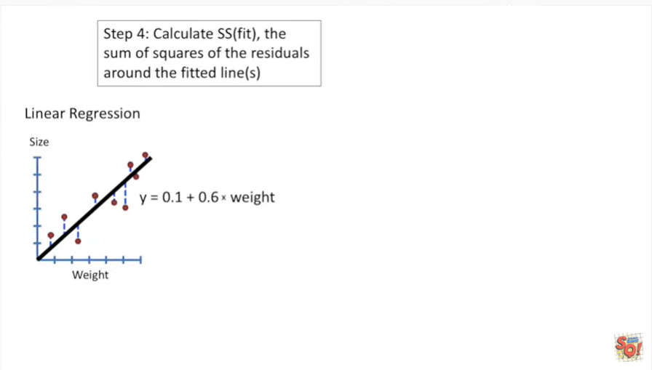

So step 4 calculate the sum of squares of the residuals around the fitted lines.

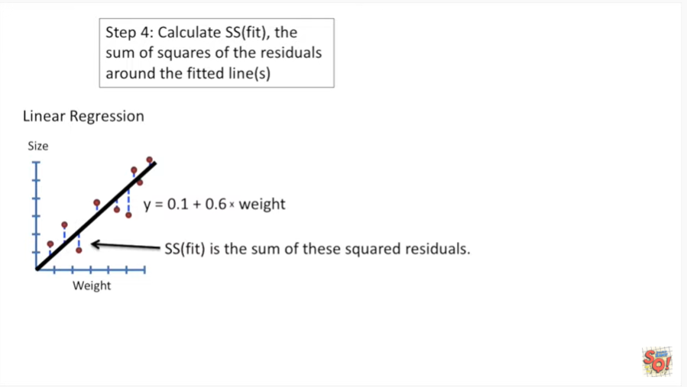

With the linear regression that means the sum of these squared residuals.

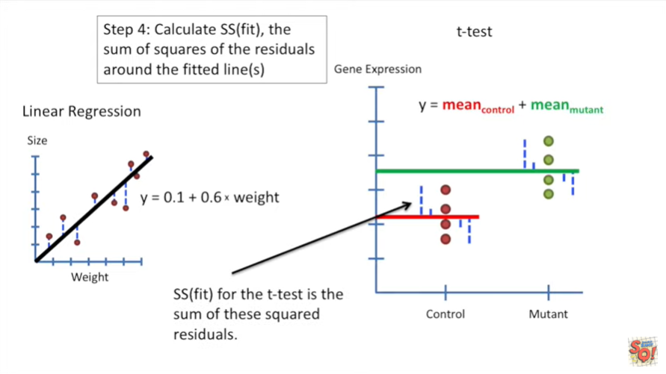

The sum of squares around the fit for the t-test is the sum of these squared residuals.

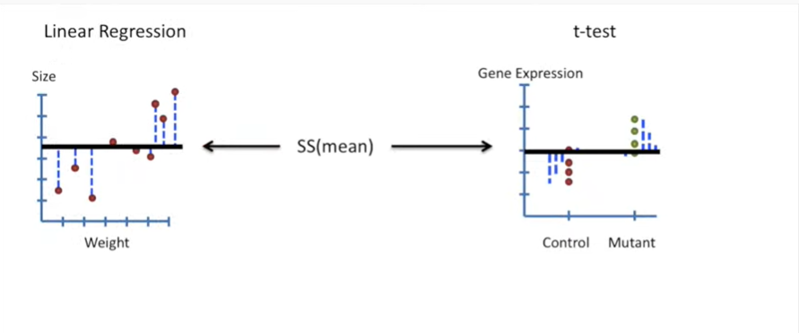

To review what we've done so far we've calculated the sum of squared residuals around the mean.

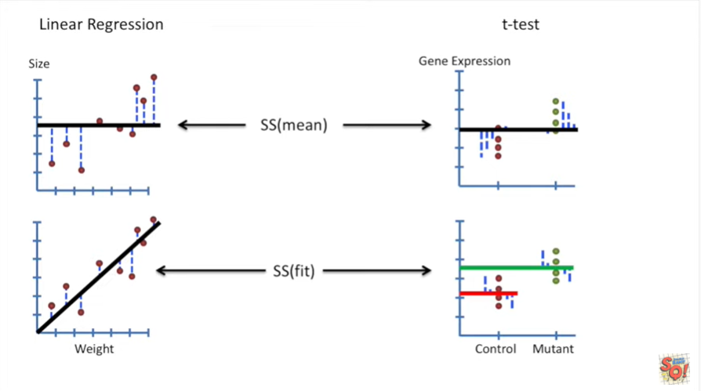

And then we calculated the sum of squared residuals around the fitted line.

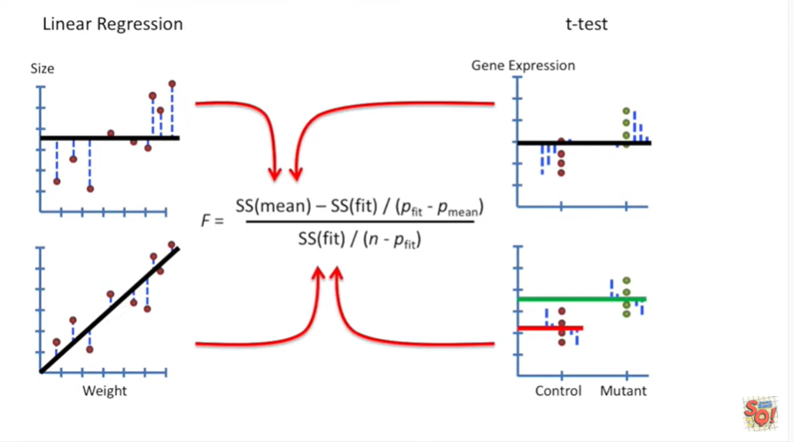

Now we can just plug these things in to our equation for F.

F will lead to a p-value.

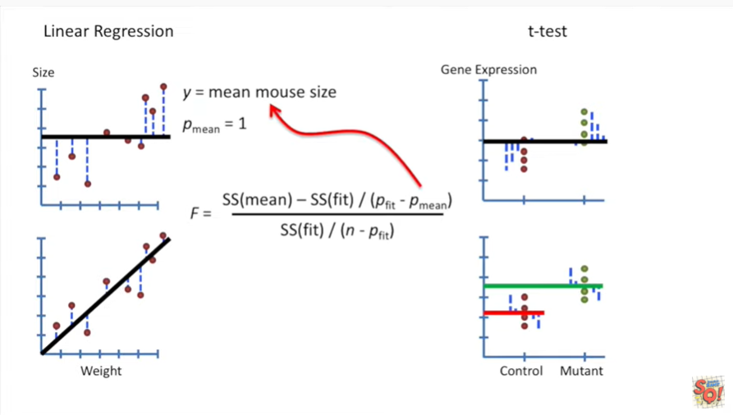

For the linear regression P mean refers to the number of parameters in the equation for the mean mouse sighs.

That's one parameter.

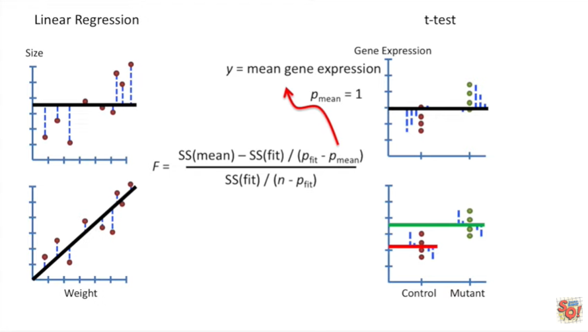  
In the t-test P mean refers to the number of parameters in the equation for the mean of the gene expression that's also just one parameter.

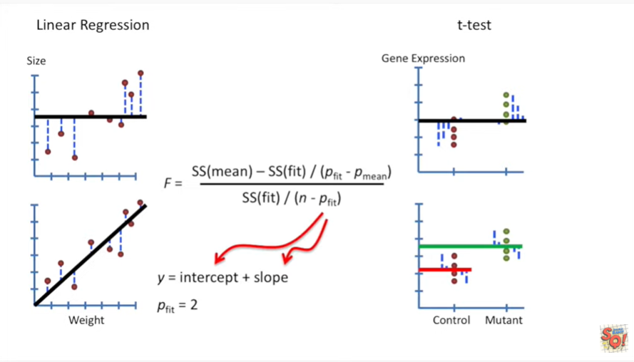

For the linear regression P fit refers to the number of parameters in the equation for the fitted line.

In this case that's two, the parameters are the intercept and the slope.

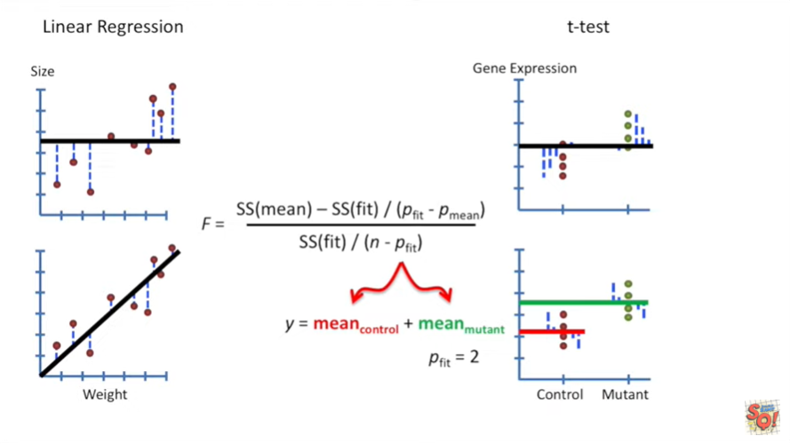

For the t-test P fifth refers to the number of parameters in the line that we fit to the t-test data.

In this case P fit equals two because we had to estimate two parameters one for the mean of the control data and one for the mean of the mutant data.

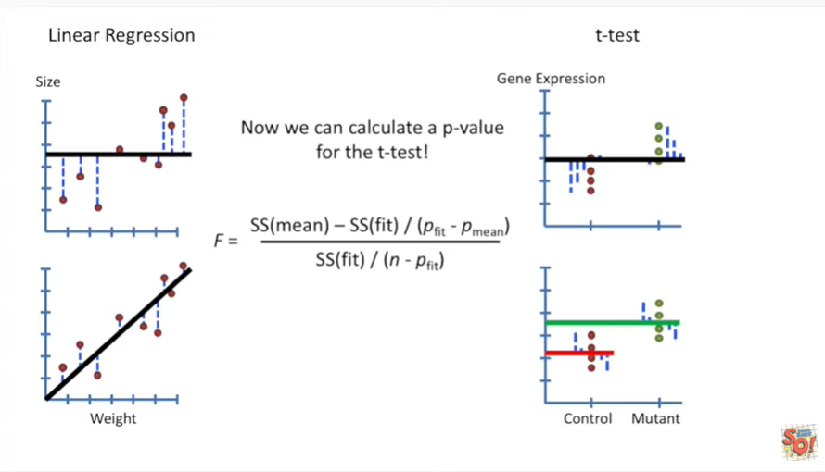

Now we can calculate a p-value for the t-test.

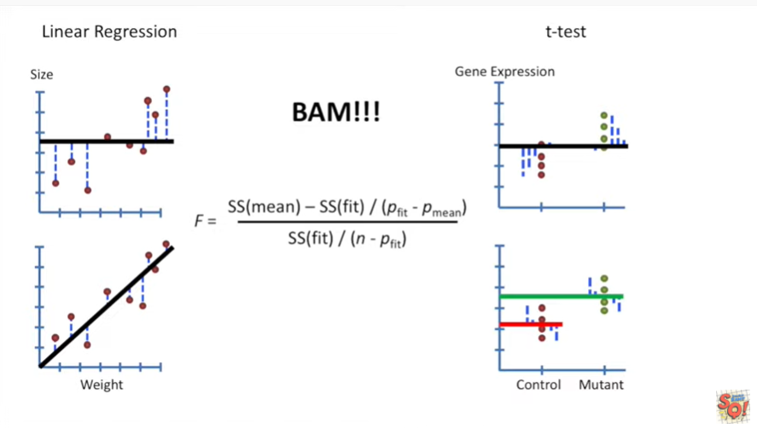

BAM.

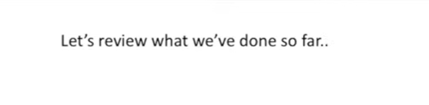

Let's review what we've done so far.

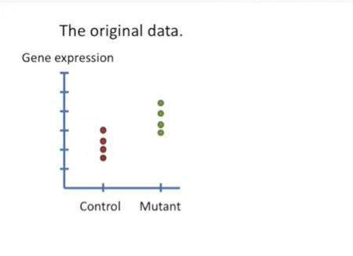

Here's the original data.

Gene expression for control mice and mutant mice.

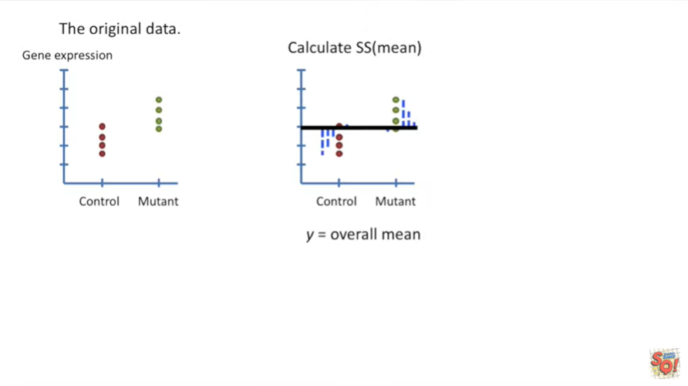

The first thing we did is we calculated the sum of squares of the residuals around the overall mean.

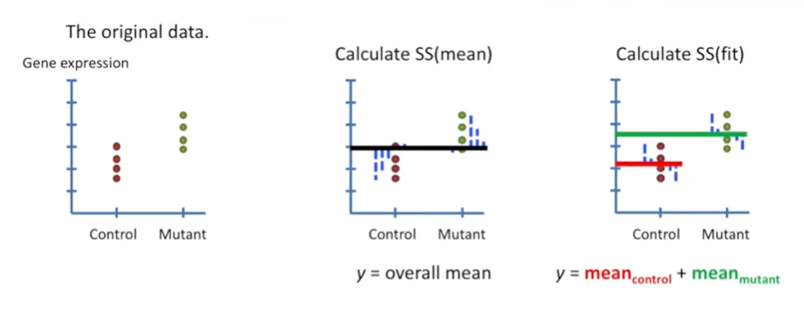

Then we calculated the sum of squares of the residuals around the fit.

In order to do this with a single equation we had to create a design matrix.

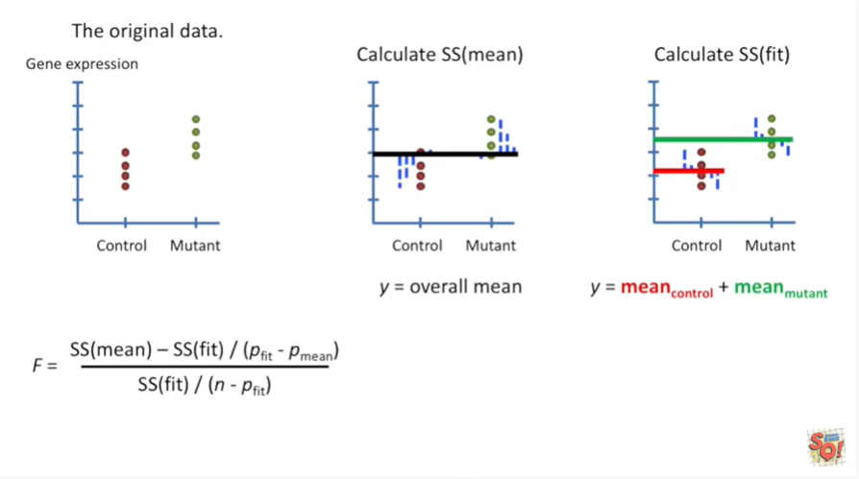

Once we've calculated the sums of squares all we have to do is plug the values into the equation for F.

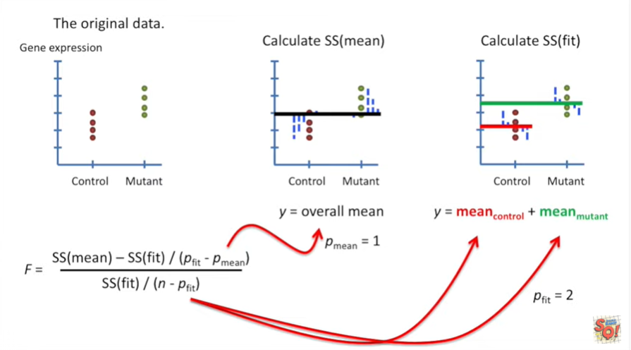

And then we'll get our p-value.

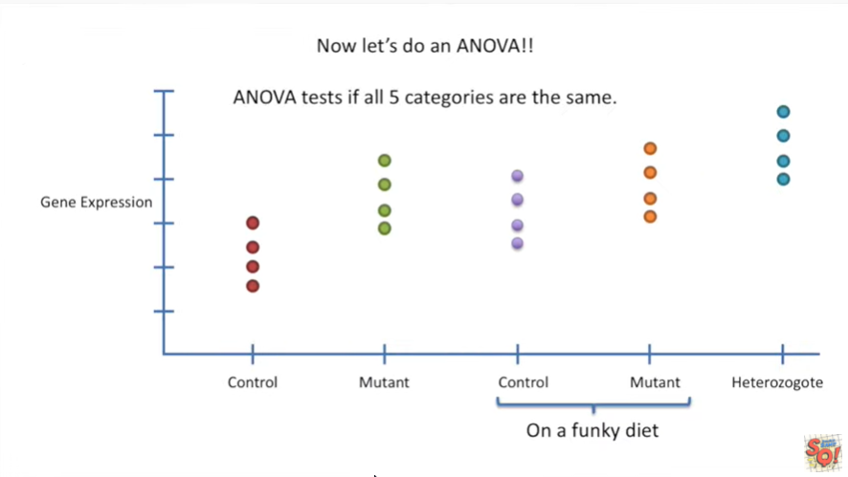

Now let's do an ANOVA.

ANOVA tests if all five categories are the same.

Here we have control and mutant mice just like before but we also have control and mutant mice on a funky diet and we also have heterozygote mice.

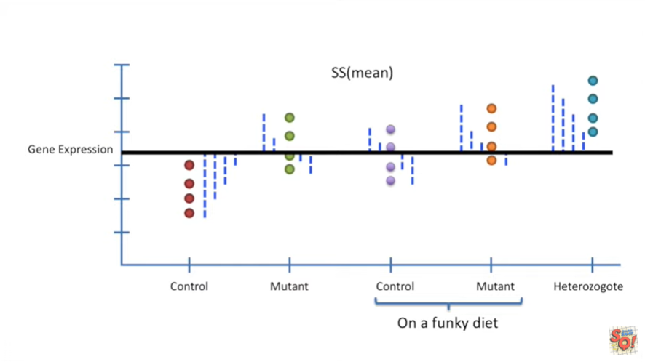

The first thing we do is calculate the sum of squares around the mean.

We do this just like before.

We calculate an overall mean value for all of the categories and then square the residuals and sum them up.

No big deal.

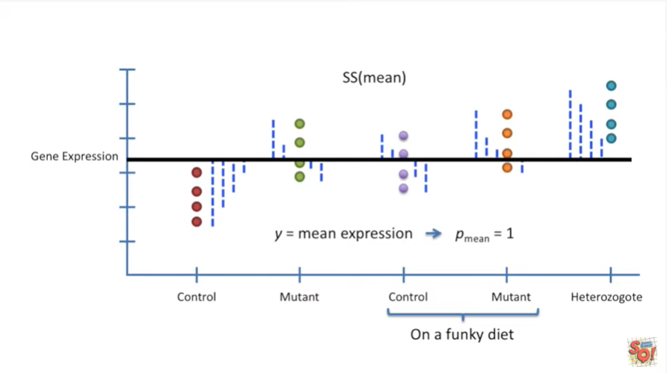

The equation for the overall mean is just y equals mean expression.

That equation only has a single parameter the overall mean.

So P mean equals one.

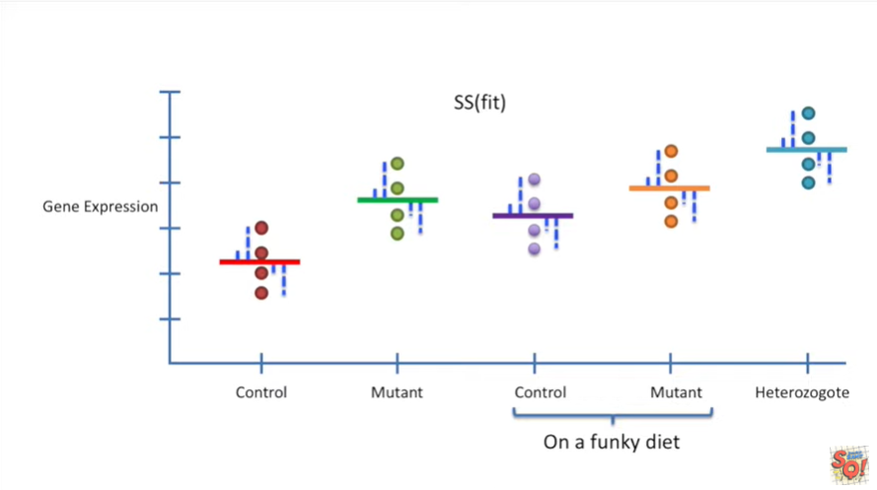

Now we calculate the sum of squares around the fitted lines.

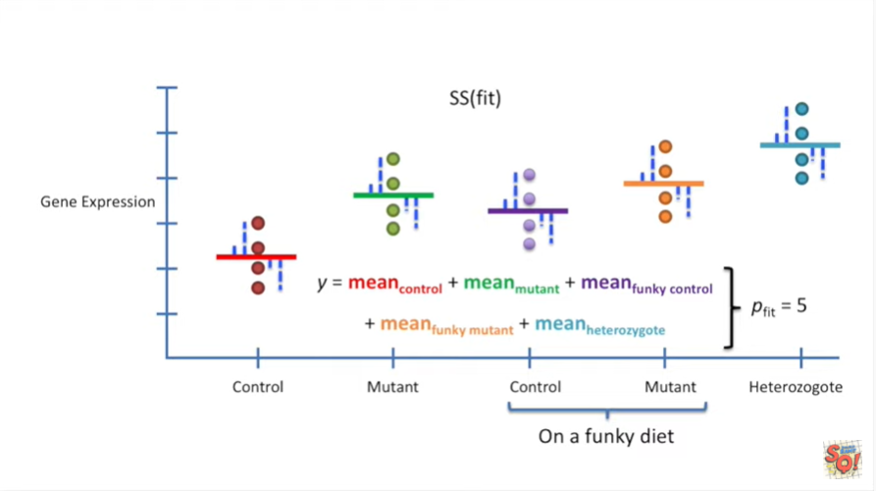

The equation for the fitted lines has five parameters.

One for each mean.

Therefore P fit equals 5.

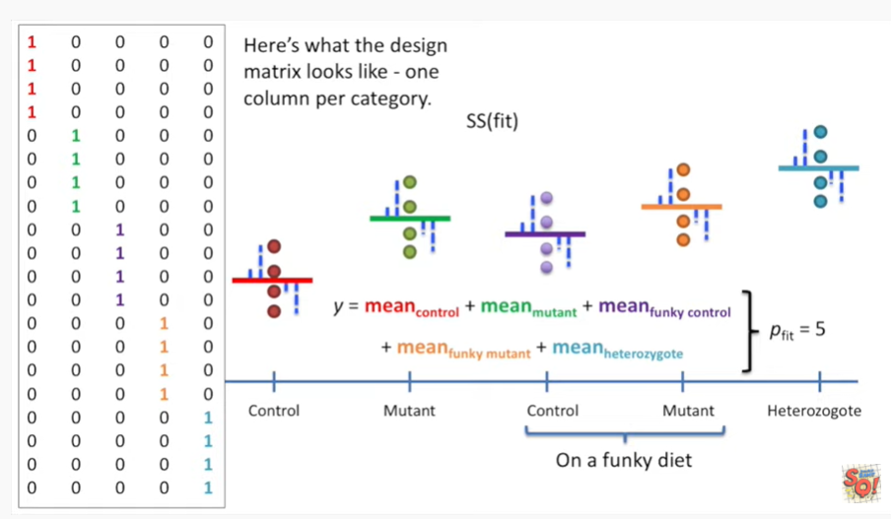

Here's what the design matrix looks like one column per category.

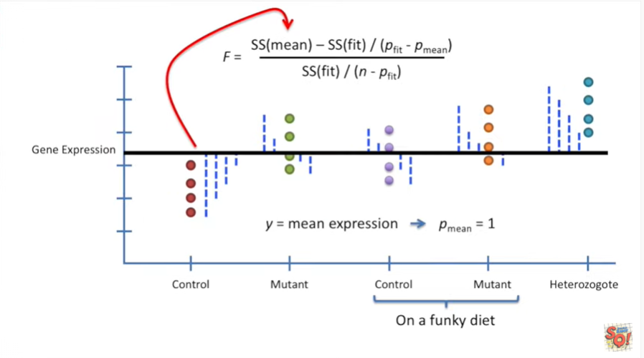

Now that we've calculated that sum of squares around the mean.

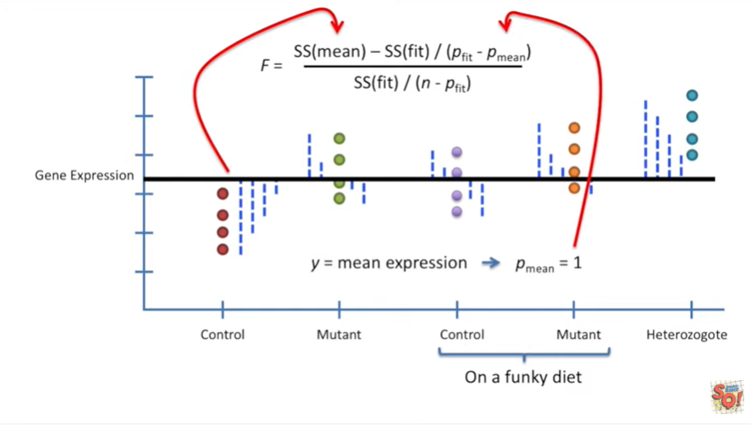

And the sum of squares around the fit.

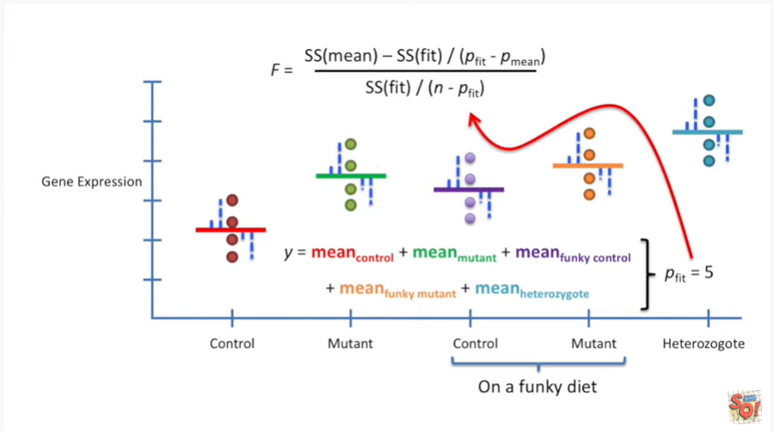

Along with P mean and P fit.

We can plug those values in and calculate F.

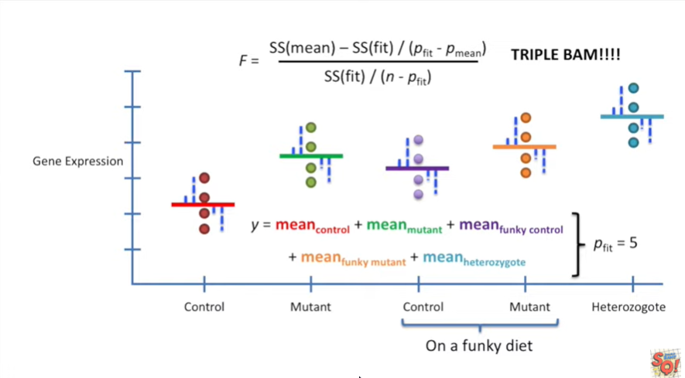

Triple BAM, if we can calculate F then we've got ourselves a p value.



One last important detail before we're done, the design matrices that I've shown you are not the standard design matrices used for doing t-tests and anova.

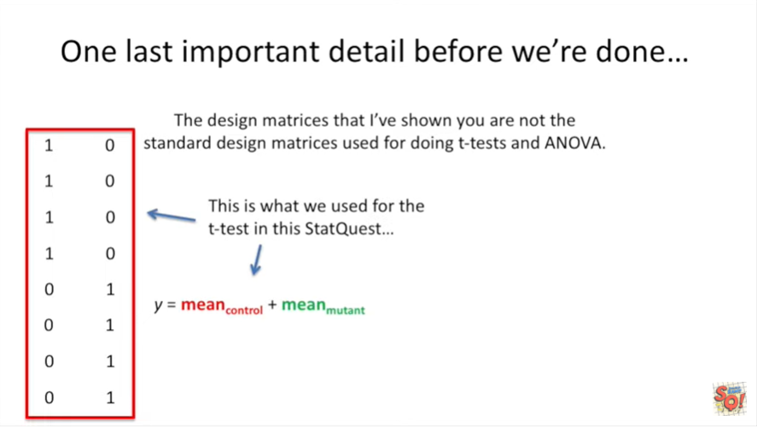

This is what we used for the t-test in this stat quest.

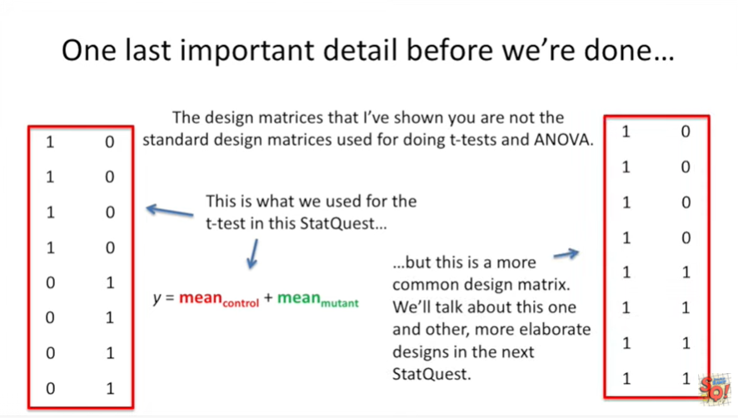

But this is a more common design matrix for the same thing both design matrices will get the job done it's just the one on the right is more commonly used.

We'll talk about this one and other more elaborate designs in the next stat quest.